BASIS DATA 3

NAMA : ARIFADHIL NURFEBRIAN

PART 5
QUIZZ 1
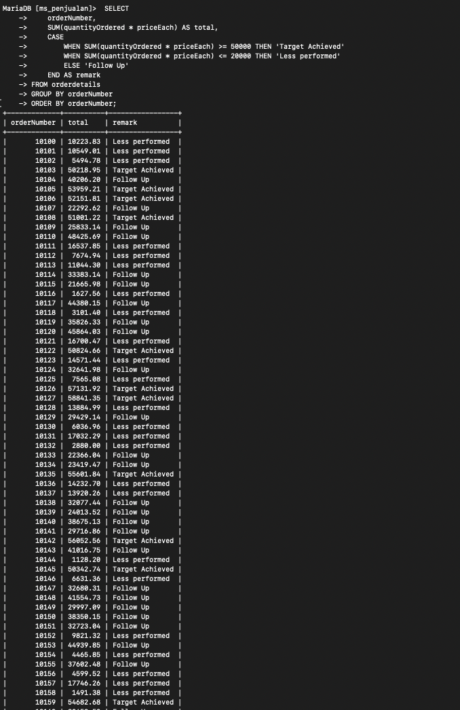
QUIZZ 2
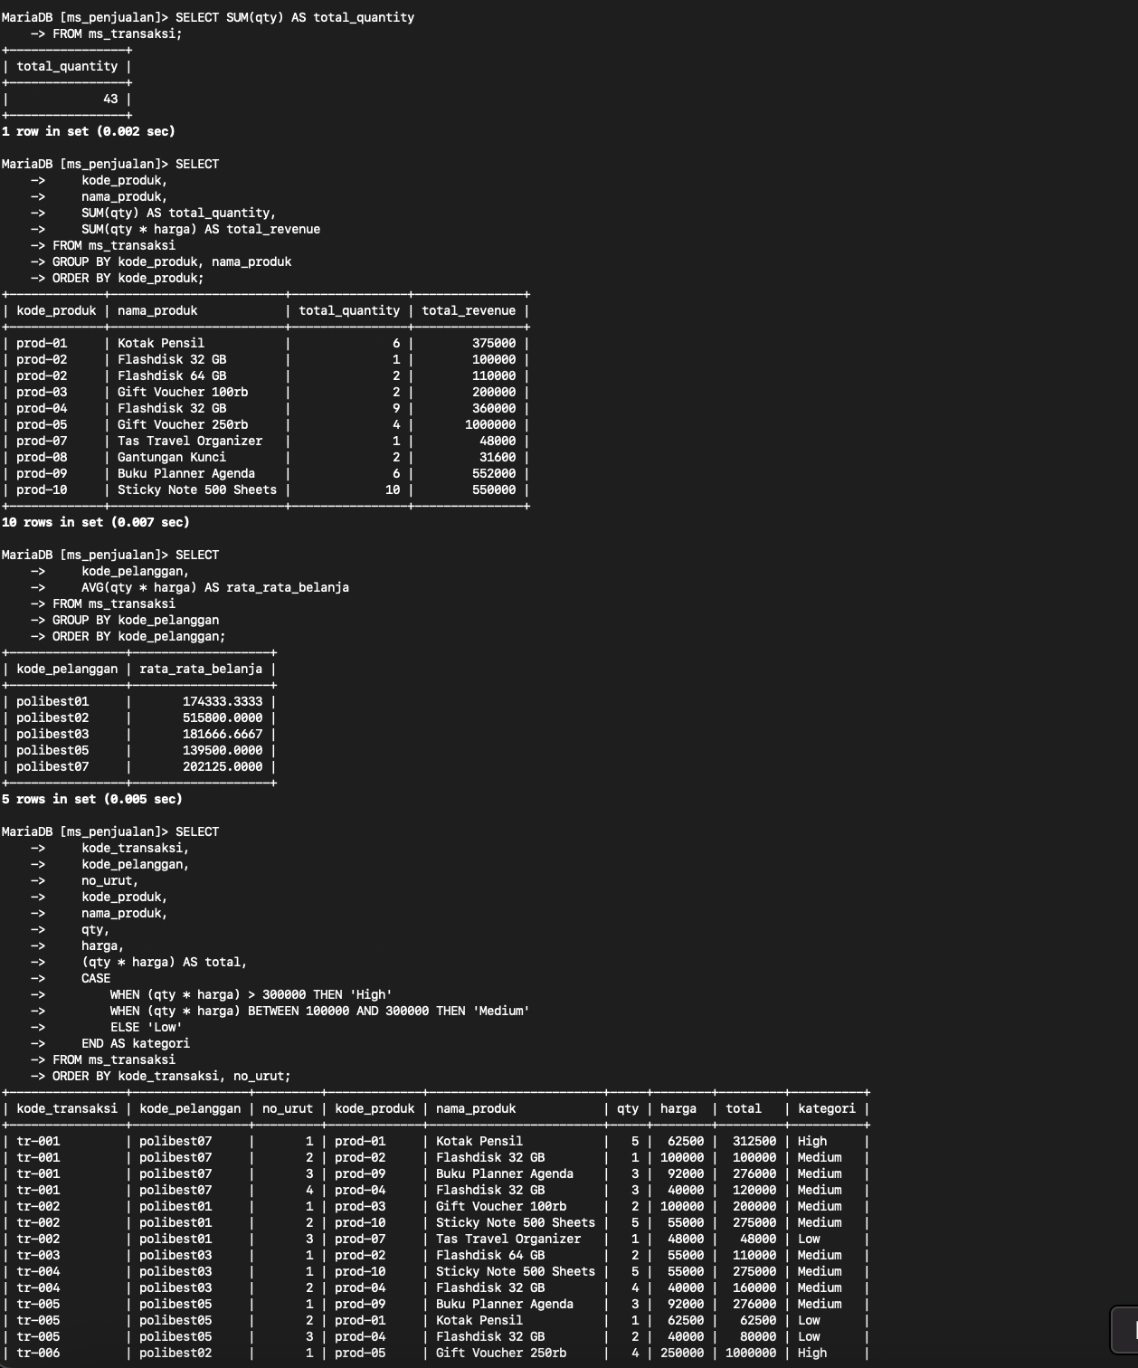

PART 6
QUIZZ 1
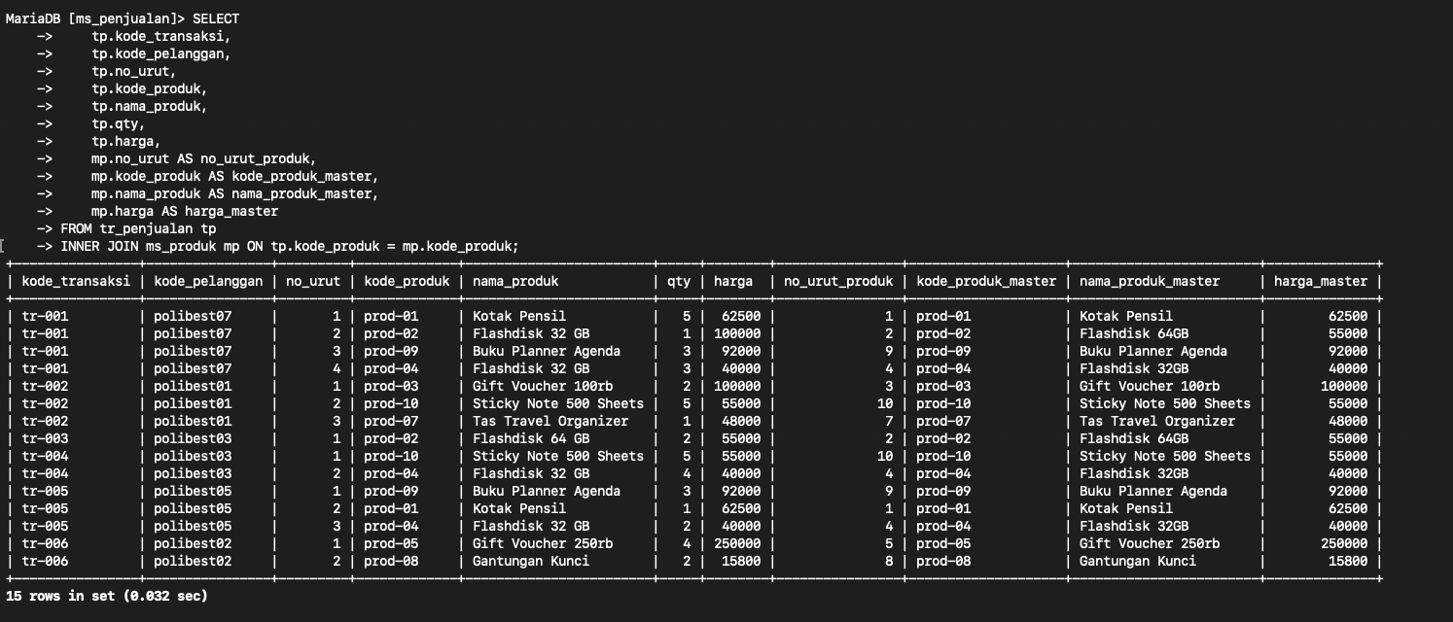

QUIZZ 2